**Classifying Pulmonary Embolism cases in Chest CT scans using VGG16 and XGBOOST**

Reshma Dua1, Ronald Wallace G 2, Tashi chotso3and Francis Densil Raj V4

1St. Joseph’s College, Bengaluru

1reshmadua11@gmail.com

2 St. Joseph’s College, Bengaluru

2ronald100799@gmail.com

3St. Joseph’s College, Bengaluru

[3choetso1996@gmail.com](mailto:3choetso1996@gmail.com)

St. Joseph’s College, Bengaluru

[4francis@sjc.ac.in](mailto:4francis@sjc.ac.in)

**Abstract.** Pulmonary Embolism, often referred to as PE is a condition in which a blood clot becomes trapped in a pulmonary artery and prevents flow of blood to the lungs. If left ignored, this might be life-threatening and, in most circumstances, fatal. Since the identification of whether a scan contains an embolus or not is a cumbersome process, we propose an approach using VGG16 and XGBOOST to classify whether an image contains an embolus or not. The dataset used has been downloaded from Kaggle and Segregated into two classes, namely ‘PE’ (The images that contain embolus) and ‘No PE’ (The images without any embolus in the lungs). Each directory contains over 1000 images. The methodology employed in this paper using VGG16 to extract features and XGBOOST to further classify images rendered an accuracy of 97.59% and a sensitivity of 97.00% with 5 misclassifications.

**Keywords:** Pulmonary Embolism, Deep Vein Thrombosis, CTPA images, ResNet-18, VGG16, VGG19, DenseNet, XGBOOST, Faster RCNN, Mask RCNN

# **1 Introduction**

Pulmonary Embolism (PE) is a condition where a blood clot occurs arteries present in the lungs. Restricting the blood flow to parts of the body, eventually leading to death. PE, in most cases is a consequence of a clot occurring in other parts of the body, mostly leg or an arm. The restricted blood flow increases the blood pressure in turn decreasing the oxygen levels in the blood.

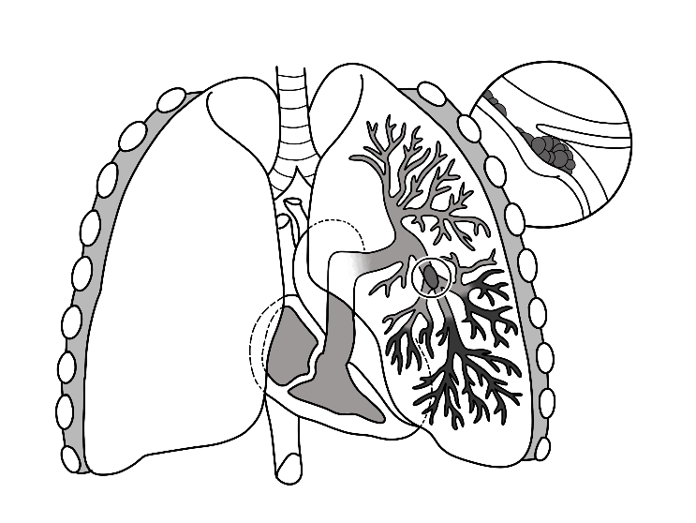

**Fig.1.** A lung illustration of PE as a blood clot

Thrombus refers to a blood clot that forms in a vein and stays there whereas an embolus occurs when a blood clot breaks free from the vein's wall and travels to another portion of your body.

‘Deep vein thrombosis’ (DVT), a disorder in which blood clots form in veins deep within the body, is the most common cause of PEs. The risk of pulmonary embolism is seen to increase with age. Higher blood pressure, stress and reduced activity seem to be contributing factors for the occurrence of pulmonary embolism in patients. Fig.2. and Fig.3., show the mortality rate of PE patients around the globe for women and men separately.

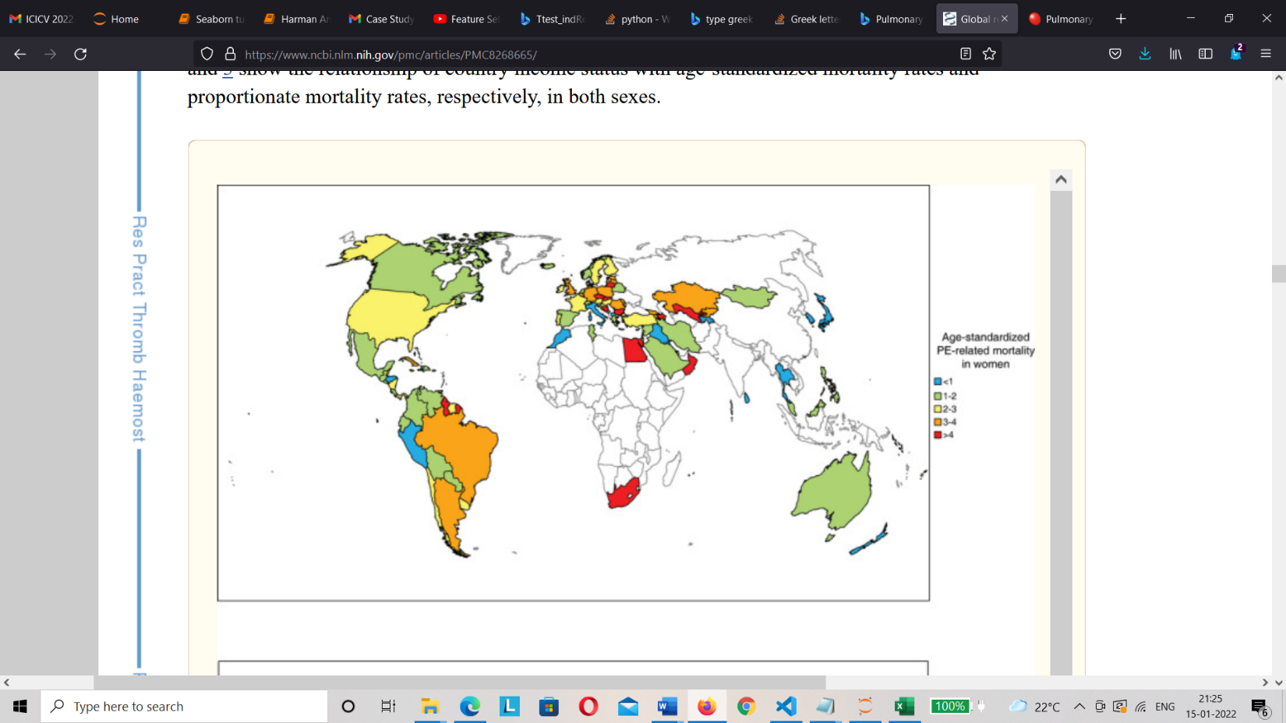

**Fig.2.** An overview of global PE-related mortality in women based on age.

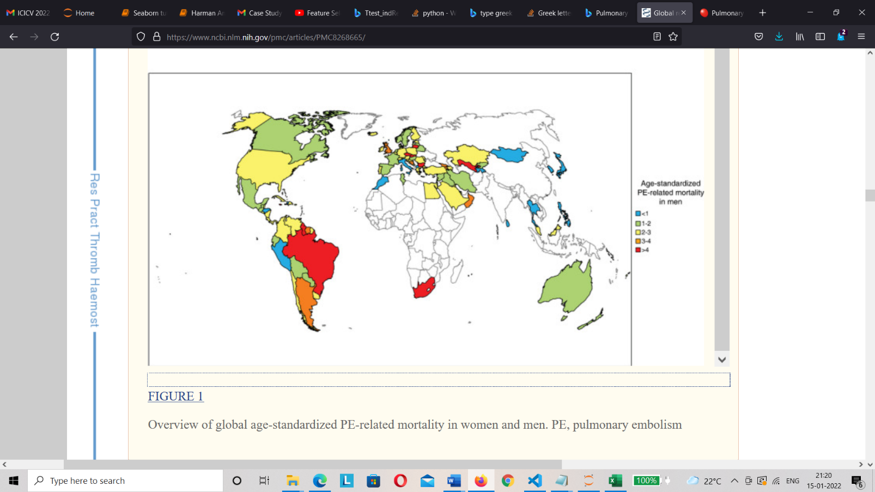

**Fig.3.** An overview of global PE-related mortality in men based on age.

The deaths caused by pulmonary embolism declined drastically in the United Kingdom between 2008-2012. The reason for the drop is still not rigidly attributed to what factors may have caused it. It might be due to the awareness of spread regarding the various causes that lead to pulmonary embolism. The age standardized mortality ratio (SMR) and the age standardized admission ratio (SAR) that represents the rate of admission of patients for the reason of pulmonary embolism is displayed state-wise in the UK –

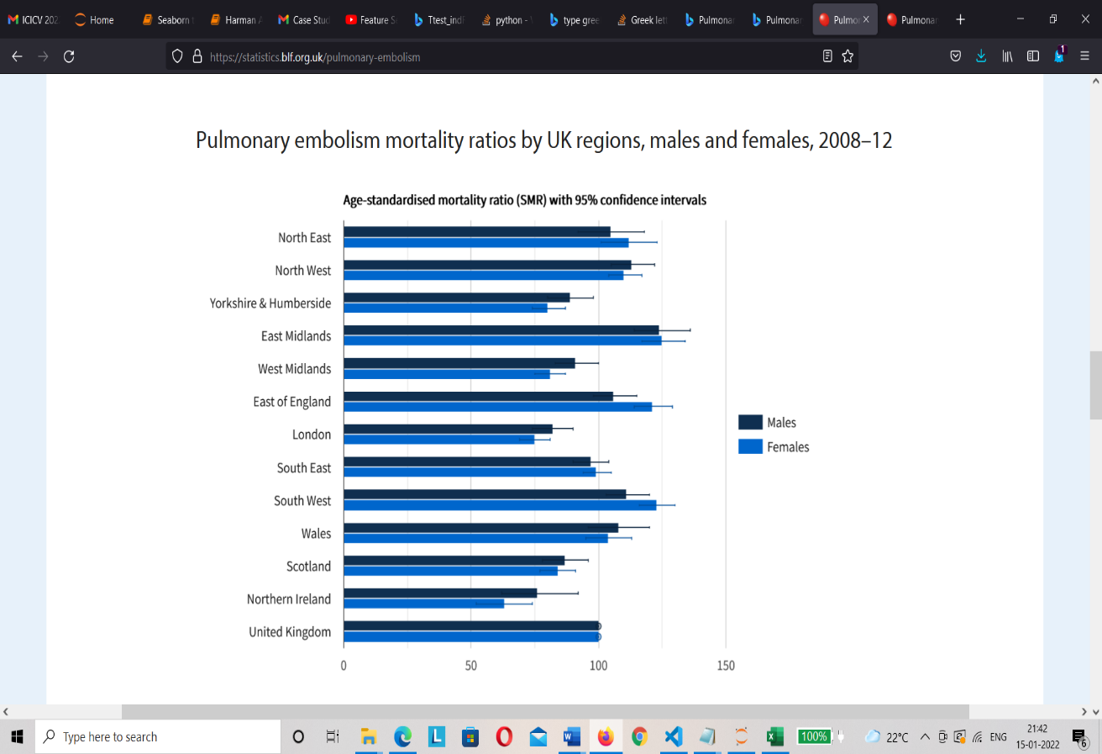

**Fig.4.** Age standardized Mortality Ratio (SMR)

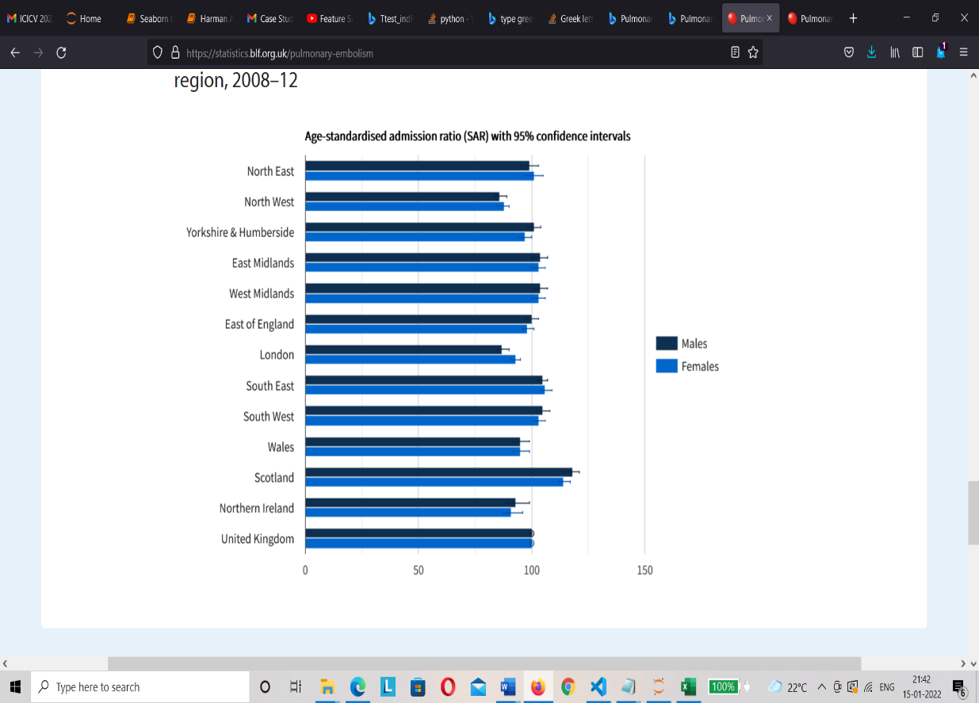

**Fig.5.** Age standardized Admission Ratio (SAR)

Though pulmonary embolism attributed to only 2% of deaths due to lung diseases in the UK, it is still one of the major underlying factor for different lung diseases that could prove to fatal.

‘Computed Tomography Pulmonary Angiography’ (CTPA) is one of the well-known method of diagnosing PE, and it can successfully reduce the mortality rate [1].

A CT scan called a 'CTPA' looks for blood clots in the lungs (referred to as pulmonary embolism or PE). The blood veins that travel from the heart to the lungs are photographed on a CT pulmonary angiography (the pulmonary arteries)

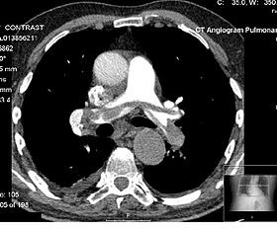

**Fig.6.** Example of a CTPA

In Fig.6. The pulmonary artery is opacified by radiocontrast in the white area above the centre. The greyish region inside is a blood clot. The lungs are the black regions on either side, with the chest wall around them.

A dye is injected into a vein in the patient's arm that leads to their pulmonary arteries during the test. On scan images, this dye makes the arteries seem bright and white. The doctor will next be able to determine whether there are any blockages or blood clots. Manually analysing a CTPA volume, on the other hand, requires an expert to trace out each and every artery and over three hundred to five hundred slices for any doubtful PEs, which takes a ton of time and prone to error due lack of experience and human error. Medical image classification is one of the most pressing issues in image recognition, with the goal of categorising medical images into different groups to aid doctors in disease diagnosis and study.

**2 Related Work**

Pulmonary embolism is a difficult disease to recognize clinically as it shares symptoms with a number of other illnesses, there are papers that help in addressing the problem, some of which are stated below.

The paper on “A novel method for pulmonary embolism detection in CTA images” identified PE where lung vessel segmentation was employed. The reliability of PE detection was directly dependent on the process of efficient vessel segmentation when lung vessel segmentation was employed, which was a crucial step in this study. The major goal of lung vessel segmentation is to achieve higher sensitivity in PE detection [2]. Familiar PE CAD methods create a chunk of false positives to obtain a clinically acceptable sensitivity, adding to the burden on the radiologists to determine these CAD findings that don’t add to value.

In the paper “Computer-aided pulmonary embolism detection using a novel vessel-aligned multi-planar image representation and convolutional neural networks”, Convolutional neural networks were experimented upon to see if they could be used as a reliable technique for removing false positives and increase sensitivity of the model. Having an 83% sensitivity at 2 false positives per volume, and a 71% sensitivity at the same rate of false positives before applying [3].

For PE detection, Yang combined a “3D fully convolutional neural network (FCN) to detect candidate regions where the embolus is likely to be present, followed by a second stage that consists of a 2D cross-section of the vessel-aligned cubes and a ResNet-18 model for classifying and extract vessel-aligned 3D candidate cubes and eliminate the false positives.” [1].

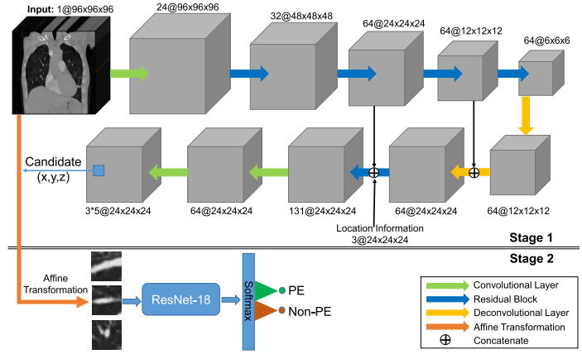

**Fig.7.** A two-stage PE detection network framework [1]

Fig.7. depicts the approach taken by Yang et al. The first stage is a 3D FCN that uses an encoder-decoder network in which the encoder The encoder decodes hierarchical feature maps, while the decoder up-samples them. This happens with the help of max pooling layers and residual blocks that are the middle layers of the FCN. Since PEs are found in some unique regions, the apparent location information is also added to the derived feature map. An FCN feature map that consists of 64 channels is directly concatenated with the 3-channel location map. In the candidate proposal subnet, anchor cubes are used to identify candidate proposals from the concatenated 3D feature map, allowing for more accurate identification of variable size. The anchor cubes, in particular, are multiscale 3D windows that are predefined and centered at each scale. The second stage uses a classifier to remove as many false positives as feasible while maintaining a high sensitivity. Since all possible Embolus’ could vary significantly in their appearance on all three cross-sections, vessel-aligned 2.5D is used to limit the apparent differences of Embolus in the three cross-section slices. Each potential proposal is aligned to the orientation of the afflicted vessel using image representation [1].

“Deep convolutional neural network based medical image classification for disease diagnosis” elaborates on clinical treatment and instructional duties and how it is critical in medical image classification. The traditional approach, on the other hand, has reached the end of its usefulness. Furthermore, In terms of extracting and selecting classification criteria, using them takes a lot of time and work. Deep neural networks are a relatively new technology in the field of machine learning (ML) that has had a considerable impact on a variety of categorization challenges. The convolutional neural network performs the best with the results for a range of image categorization tasks. Medical image databases, on the other hand, are pretty hard to come by because labelling them requires an elite level of expertise. As a response, the focus of this research is on how to classify pneumonia on chest X-rays using a convolutional neural network (CNN)-based technique[4].

Experiments are used to evaluate three strategies. Among these are a linear SVM classifier with local rotation and orientation free features, transfer learning on two CNN models (VGG16 and InceptionV3), and a capsule network created entirely from scratch.

Data augmentation is a strategy for preparing data that can be utilized with any of the three methods. The findings imply that using data augmentation to improve the performance of all three algorithms is a solid technique.

Transfer learning is also more beneficial when it comes to classification tasks especially on small datasets, when compared to support vector machines with oriented fast and rotated binary (ORB) robust independent elementary features and capsule network.

Individual features must be retained on a new target dataset to increase transfer learning performance. The second important constraint is network complexity, which must be proportional to the dataset size.

S. Ren etal proposed a complex convolutional neural network with nonlinear activation function on raw images to segment out the region of interest. A U-net model was also employed to manage the size of the data [5].

“O. Ronneberger, explains the working of Faster R-CNN and the Choice of Region Proposal networks over Traditional selective search methods to make 300 proposals per image”. Their model also employs a image -convolutional layer to obtain the feature map and a 3x3 window that traverses through the feature map that results in K-number of anchor boxes. The “k” class outputs the probability of the box containing the object. Using RPNs and Faster R-CNN, object detection accuracy was observed on PASCAL VOC 2007 (73.2 percent mAP) and 2012 (70.4 percent mAP). [6].

The paper “Deep residual learning for image recognition” explains the degradation problem by introducing a deep residual learning framework. Deep residual nets are simple to optimize, however "basic" residual nets (which merely stack layers) have increased training error as the depth grows. Deep residual nets can also benefit from the additional depth in terms of accuracy, delivering results that are far better than earlier networks. The authors have given extensive ImageNet tests to demonstrate the degradation problem, and their method has been evaluated as a result [7].

In the study, “Accurate Pulmonary Nodule Detection in Computed Tomography Images Using Deep Convolutional Neural Networks” a pulmonary nodule detection CAD system is proposed which is implemented using deep convolutional networks, a deconvolutional improved Faster R-CNN is constructed to discover nodule candidates from axial slices, and a 3D DCNN is then used to reduce false positives. The suggested CAD system ranks first in the Nodule Detection Track (NDET) with an average FROC-score of 0.893, according to experimental data from the LUNA16 Nodule Detection Challenge.

Based on an evaluation of the error and backpropagation approach, Mingyuan Xin et al developed a unique deep neural network ton the basis of fulfilling the conditions of maximum interval minimal classification error during training. To achieve metrics with enhanced outcomes, the cross entropy and M3CE are analysed and integrated at the same time. Finally, we put our suggested M3 CE-CEc to the test on MNIST and CIFAR-10, two deep learning standard databases. According to the findings, M3 CE can increase cross-entropy and can be used in addition to the cross-entropy criterion. In both datasets, M3 CE-CEc performed admirably. [8].

Bashar, Abdul in their paper on “Survey on evolving deep learning neural network architectures.”, addresses the scope of deep learning neural network, convolutional neural networks in specific in the field of speech recognition, image recognition, natural language processing. It also explains various fields of study in which deep neural networks are proven to be prominent. The importance of Deep Learning is stated as they are observed to outweigh human performance and differ from traditional machine learning techniques by enabling automatic feature extraction [9].

Vijaykumar. T explains the reliability of capsule neural networks in comparison to the Convolutional neural networks that despite their hype are prone to loss in performance due to the process of reduction of dimensions for acquiring spatial invariance. The working of CapsNets are emphasised in which the author states that the Capsule neural networks take care of the performance degradation problem seen in convolutional neural networks. They accomplish this by dividing the total pictures into sub-parts and hierarchically relating them, resulting in a picture with even higher resolution than the CNN. The CNN's pooling layer ignores the location connection in the features, resulting in performance degradation, whereas the capsule shows effective feature extraction, thereby improving classification accuracy. [10].

The paper “Study of variants of extreme learning machine (ELM) brands and its performance measure on classification algorithm” described the variant of EML with various machine leaning algorithm and compared its accuracy and execution time. Deep learning technologies are now widely applied in a variety of fields. Feed-forward neural networks are used in deep learning to train and test models with high accuracy, although the feed-forward network has a long computation time and a high gain. The ELM algorithm can overcome the disadvantage of the FFNN being a rebuilt neural network containing network components including hidden nodes, weights, and biases. [11].

In the paper “Artificial Intelligence Algorithm with SVM classification using Dermascopic Images for Melanoma Diagnosis” Clinicians use an ordinal scale of 1 to 4 to determine the likelihood of melanoma, with 4 being the most likely and 1 indicating the least likely. The chance of melanoma in all biopsied lesions is estimated, and the clinical accuracy of the evaluation is compared. It generated sensitivity of 95 % and 100% with using multiple decision thresholds.

The proposed AI algorithm with SVM classification is done on images obtained from digital single-lens reflex(DSLR) cameras with specificity and sensitivity 70% and 100% respectively [12].

The paper on “Analysis of Convolutional Neural Network based Image Classification Techniques” proposes a method to classify fruits employing the activation function to determine the most essential aspects of the images by adjusting parameters or feature detectors to the input image in order to build feature maps or activation maps The suggested system is seen in Figure 8 as a whole.

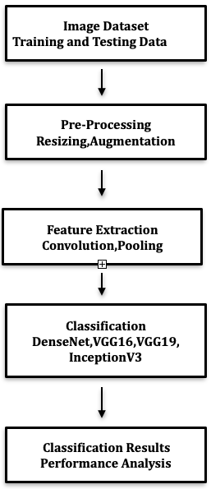

**Fig.8.** Overview of the Proposed System [13]

The suggested deep learning-based image classification method involves using a DenseNet-based model to identify images more successfully than other classifiers, with training and testing accuracy of 99.25% and 100%, respectively. [13].

CNN is especially good in extracting spatial characteristics. However, visual noise easily interferes with the single-layer classifier built by the activation function in CNN, resulting in lower classification accuracy. The sophisticated ensemble model XGBOOST is utilised to tackle the problem and overcome the limitations of a single classifier in classifying picture features. A CNN-XGBOOST image classification model optimised by APSO is presented to further discriminate the extracted image features, with APSO optimising the hyper-parameters on the overall architecture to encourage the fusion of the two-stage model. The model is made up of two parts: a feature extractor CNN that extracts spatial characteristics from images automatically, and a feature classifier XGBOOST that classifies the extracted features after convolution. To overcome the shortcoming of traditional PSO algorithms easily falling into local optima, the improved APSO guides the particles to search for optimization in space using two different strategies, improving particle population diversity and preventing the method from becoming trapped in local optima. The picture set findings suggest that the proposed model performs better in image categorization. Furthermore, the APSO-XGBOOST model performs well on credit data, indicating that it is capable of credit rating [14].

**Comparative Study**

Below is a comparative study of a few reference papers from the literature review based on the methodology employed and the results obtained.

|  |  |  |
| --- | --- | --- |
| **Paper** | **Methodology** | **Evaluation Metric** |
| “A Two-Stage Convolutional Neural Network for Pulmonary Embolism Detection From CTPA Images” | Resnet-18 | Sensitivity (75.4%) |
| “Computer-aided pulmonary embolism detection using a novel vessel-aligned multi-planar image representation and convolutional neural networks” | CNN | Sensitivity (83%) |
| “U-net: Convolutional networks for biomedical image segmentation” | U-net | accuracy (77.5) |
| “Artificial Intelligence Algorithm with SVM Classification using Dermascopic Images for Melanoma Diagnosis” | AI with SVM | sensitivity (100%)  specificity (70%) |
| “Accurate Pulmonary Nodule Detection in Computed Tomography Images Using Deep Convolutional Neural Networks” | CAD system | FROC-score (89%) |
| “U-net: Convolutional networks for biomedical image segmentation” | RPN and Faster R-CNN | accuracy( 70.4%) |
| “A novel method for pulmonary embolism detection in CTA images” | CAD | sensitivity (95.1%) |
| “Analysis of Convolutional Neural Network based Image Classification Techniques” | DenseNet | training accuracy:  (99.25%)  testing accuracy:  (100%) |
| “Deep convolutional neural network based medical image classification for disease diagnosis” | Capsnet | 74% |

**3 Experiment Design**

**3.1 Dataset**

**The RSNA STR Pulmonary Embolism Dataset**

The Radiological Society of North America(RSNA) has partnered up with the Society of Thoracic Radiology (STR) to increase the use of machine learning in the diagnosis of PE [15]. We have evaluated our method on the RSNA STR PE Detection Dataset available on Kaggle for academic research and education.

**File Description**

**“train.csv** contains UIDs and labels which is the metadata for all images.”

**“Dataset** contains two subdirectories for positive and negative PE cases.”

**Data Fields**

“**Study Instance UID** is the unique ID for each study in the dataset.”

“**Series Instance UID** is the unique ID for each series within the study.”

“**SOP Instance UID** is the unique ID for each image within the study.”

“**pe_present_on_image** indicates the image-level, notes whether any form of PE is present on the image.”

The images were downloaded from Kaggle in .jpg format and the train.csv file was used to segregate the images into two classes, namely ‘PE’ (The images that contain embolism) and ‘No PE’ (The images without any embolus in the lungs) based on “pe_present_on_image” column.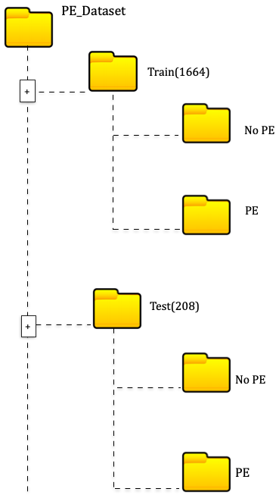

**Fig.9.** Image split in different directories

**3.2 Creating Train and Test subsets**

After the segregation of images into two different classes we split the data into train and test data such that there are 832 images in the train set and 104 images in the test set. This is done so that our model will have enough data with variety to learn from and render better reliability and performance.

**3.3 Model Building**

Image interpretation by computer programmes has been an important and active topic in the machine learning discipline, as well as in application and research specific investigations, due to the rapid growth of digital image collecting and storage technology. Medical image classification is a challenging task in Deep Learning which tries to classify medical images into distinct categories to aid doctors and radiologists in diagnosing disease or doing additional study.

The classification of medical images can be broken down into two parts. The first step is to take a photograph and extract information from it. The characteristics are then used to classify the image collection and generate models in the second stage. Doctors/radiologists formerly used their professional experience to extract features from medical images in order to classify them into distinct classes, which was a tedious, monotonous, and time-consuming task. The approach to classify the medical image is time consuming if done manually. Medical image classification application study has a lot of merit, based on previous research. The efforts of the scholars have resulted in a huge number of published works in this field.

However, we are still unable to complete this mission effectively at this time. If we can complete the classification process well, the data will aid medical doctors in diagnosing disorders that require further investigation.

As a result, figuring out how to complete this duty properly is crucial, and the topic of our paper.

**3.4 Proposed Methodology**

The methodology proposed aims to classify Pulmonary Embolism CTPA scans correctly into PE and No PE with minimal misclassifications. The flowchart below illustrates the procedure step by step.

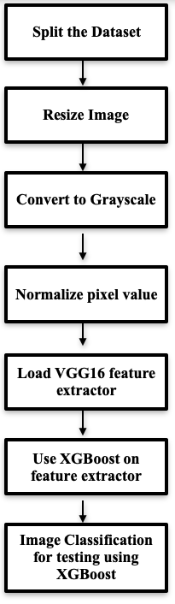

**Fig.10.** Flowchart of Proposed Methodology

Visual Geometric Group-16(VGG16) is a Convolutional Neural Network (CNN) model which is used a lot in medical image classification and detection. It consists of 16 layers which have tunable parameters out of which 13 layers are convolutional layers with non- linear activation function(ReLu) and 3 fully connected layers with the same non-linear activation function. In addition to these 16 convolutional layers there are Max Pool layers for reducing the dimensions of the feature map and dense layers with the Softmax activation function that renders classified output.

Every convolutional layer has a receptive field of 3x3 and a stride of 1. The VGG16 takes in images in the size of 224x224. It uses row and column padding to maintain spatial resolution after convolution. The Max Pool window size is observed to 2x2 with a stride of 2. Not all convolutional layers are followed by max-pool layer. The first two fully connected layer contain 4096 channels each and the final fully connected layer contains 1000 channels. The last layer is a softmax layer with 1000 channles, one for each class of images in the dataset. VGG16 is also a go-to-model when one has very few images to train on.

We have made use of the model to extract features from the images and the input layer which is a convolutional layer takes in a fixed image size of 256x256 instead of 224x224.

Dense layers are dropped as a classification task is taken care of by the XGBOOST model that succeeds VGG16, only convolutional layers are used to extract features and these features are then flattened and fed into the XGBOOST for classification.

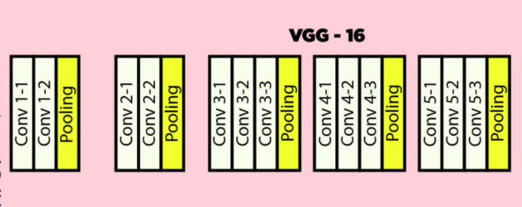

**Fig.11.** VGG-16 Architecture map for feature extraction

The features of shape (8,8,512) are extracted from the VGG16 model and flattened to 32768. These features are used to train the XGBOOST model, which uses Gradient Boosted decision trees to function on the notion of extreme gradient boosting. Weights are assigned to all of the independent factors, which are then input into the decision tree, which predicts outcomes. The weight of variables predicted wrongly by the first decision tree is increased, and these variables are subsequently put into the second decision tree. After then, the separate classifiers/predictors are integrated to create a more powerful and precise model. After the model has been trained on the retrieved features, the test set is subjected to the same feature extraction and reshaping process to determine the model's performance.

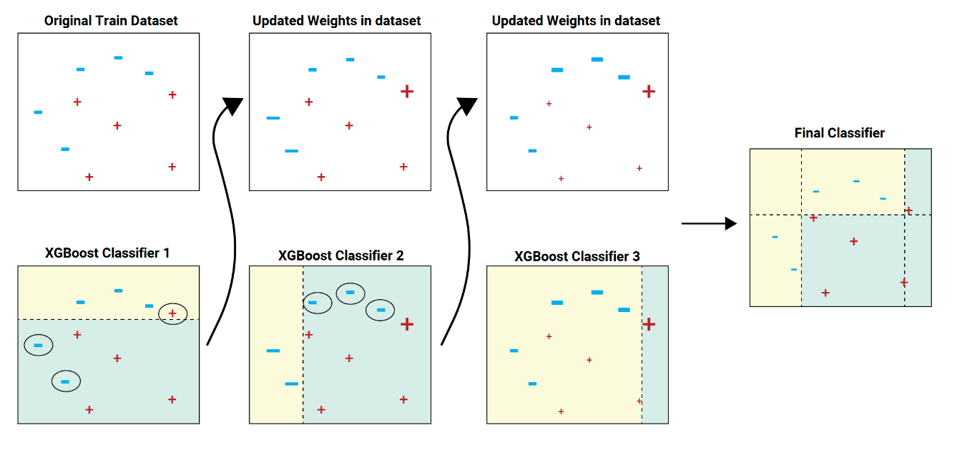The process of how XGBOOST model arrives at a better hypothesis using outputs from number of weak leaners is illustrated in the image below –

**Fig.12.** Working of XGBOOST algorithm

**4 Results**

Fig.13. represents the confusion matrix which describes the performance of our model on test data. The proposed methodology has performed well with very few misclassifications- 5 out of 104 unseen test data points.

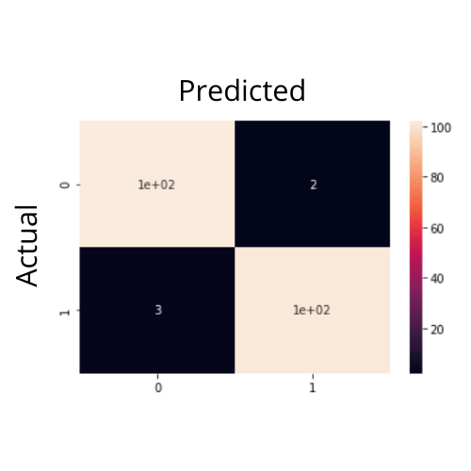

**Fig. 13.** Confusion matrix

Fig.14. represents the classification report that is used to assess the quality of predictions made by the algorithm.

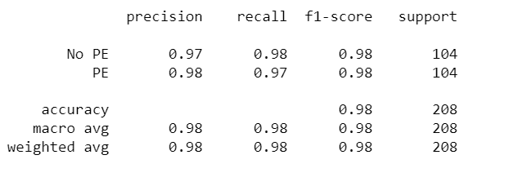

**Fig.14.** Classification Report

The classification report includes various metrics used for evaluation of our model such as –

Precision which gives us the percentage of correctly classified images of the in both the classes, Recall or the true positive rate explains the ability of our model to classify whether a particular image belongs to a certain class, the f1 score, a classification metric that combines the values of both precision and recall to give an overall measure of model performance. The accuracy is seldom used as a classification metric, but in our case, since the number of images in either of the classes are equal we can also calculate the accuracy that determines the percentage of correctly classified images of the model. Specificity or true negative rate is a metric that evaluates a model’s ability to predict if an image does not belong to a certain class. The misclassification rate depicts the number of misclassified images with respect to the total number of images in that particular class. The formulas for the above metrics are given as follows –

Our model achieves an accuracy of 97.59% and an overall sensitivity of 97.00%, i,e; The model can successfully predict if a given image does not belong to a particular class 97 times out of 100. For The "PE" class the sensitivity is observed to be 97.00% and for the "No PE" class it is seen to be 98.00% respectively. The misclassifications are also very low at about 5 misclassifications out of 104 unseen images which leaves us with a misclassification error rate of 4.80%. As for the Precision, Recall and f1-score, Our model achieves a precision of 98.00% on the "PE" class and 97.00% of the "NO PE" and a recall of 97.00% on the "PE" class and 98.00% on the "NO PE" class respectively. f1-score of our model is observed to be 98.00% for both the classes.

An ROC curve in Fig.15. is a graph showing the performance of a classification model at all classification thresholds. This curve plots two parameters:

* True Positive Rate (TPR)
* False Positive Rate (FPR)

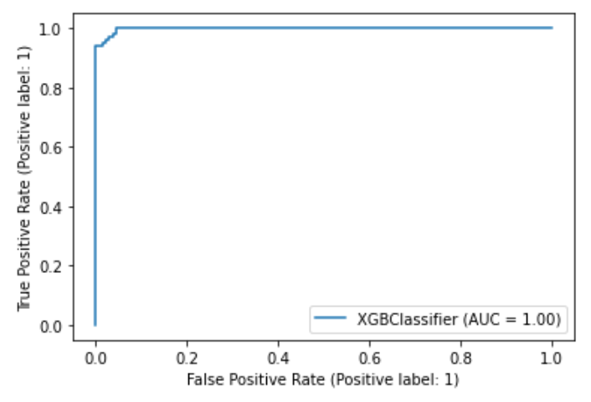

**Fig.15.** Receiver Operator Characteristic (ROC) curve

Classifiers that give curves closer to the top-left corner indicate a better performance and hence our proposed classifier (XGBOOST built on top of VGG16) has proven to perform better.

# **5 Conclusion**

This paper represents a VGG16 model in combination with boosting technique (XGBOOST) to successfully classify the images into two classes.

Prior to selecting the model stated above, different models and techniques were experimented on, but they did not prove to be effective due to the lack of data needed to feed the model. ResNet50 was one of the architectures that was used, rendering a validation accuracy of 71.98%.

Since there was a constraint on the number of images available for building our model an alternative and a much more effective way was employed in which a VGG16 model was used for feature extraction, which is observed to perform well on medical images in combination with Boosting techniques (XGBOOST). This technique on the other hand, was observed to perform much better than all other techniques with an accuracy of 97.59% and a sensitivity of 97.00% with 5 misclassifications. Alternate approach is also mentioned in the literature review section, which describes a two-stage approach to classify and detect 3D images.

# **6 Future Scope**

Now that we have successfully constructed a model to classify our image to whether it has an embolus or not, our next task is to optimize this objective by coming up with methods that would serve the purpose of localising and segmenting the embolism without compromising on the efficiency of our model.

A model that uses an instance segmentation method to segment the clot from an image can be used. Though the images acquired are not annotated and the approximate coordinates are unknown, VGG image Annotator software can be used to segment the area where the clot is likely to be present. The annotated images are then used to train models that use the principle of object detection and image segmentation. Mask RCNN would be a better model to start from and proceed further as it is shown to perform well with medical data. This method comprises of two stages –

# **STAGE-1: ANNOTATION OF IMAGE**

The segment where the clot is likely to be present in the image is annotated using VGG image Annotator software. This is done for about 30-40 images. These many images would suffice for this approach of classifying the images and most models that use instance segmentation approach tend to perform better with the number of images stated above.

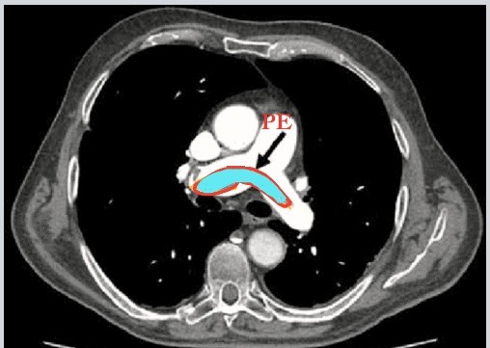

**Fig.16.** Segmented Pulmonary Embolus

Fig.16. is annotated using the annotation software – VGG image annotator, the segmented part is where the embolus is observed to be present in the lungs of the patient

# **STAGE-2: MODEL BUILDING AND OPTIMISATION**

The next step in the process is to train a model like Mask RCNN on the annotated images and use it to segment embolus from the CTPA images and optimise it.

# **7 References**

|  |  |
| --- | --- |
| 1. | X. Yang, “A Two-Stage Convolutional Neural Network for Pulmonary Embolism Detection from CTPA Images,” *IEEE Access, vol.7,* (2019). |
| 2. | “Pulmonary Embolism imaging and outcomes,” *AJR American Journal of Roentgenology,* (2012). |
| 3. | O. O. S. .. a. A. F. B. H. Özkan, “A novel method for pulmonary embolism detection in CTA images,” *Comput. Methods Programs Biomed,* Vols. vol. 113, no. 3, pp. 757 766, (2014). |
| 4. | S. J. S. D. Yadav, “Convolutional neural network based medical image classification for disease diagnosis,” Vols. J Big Data 6, 113 , (2019). |
| 5. | M. B. G. a. J. L. N. Tajbakhsh, “Computer-aided pulmonary embolism detection using a novel vessel-aligned multi-planar image representation and convolutional neural networks,” *Springer,* (2015). |
| 6. | P. F. a. T. B. O. Ronneberger, “U-net: Convolutional networks for biomedical image segmentation,” vol. pp. 234–241, (2015). |
| 7. | X. Z. S. R. a. J. S. K. He, “Deep residual learning for image recognition,” *IEEE,* vol. pp. 770–778., (2016). |
| 8. | M. W. Y. Xin, “Research on image classification model based on deep convolution neural network,” (2019). |
| 9. | A. Bashar, “Survey on evolving deep learning neural network architectures,” *Journal of Artificial Intelligence 1,* vol. no. 02, pp. 73-82, (2019. |
| 10. | T. Vijayakumar, “Comparative study of capsule neural network in various applications,” *Journal of Artificial intelligence 1,* vol. no. 01, pp. 19-27, (2019). |
| 11. | J. S. Manoharan, “Study of Variants of Extreme Learning Machine (ELM) Brands and its Performance Measure on Classification Algorithm,” *Journal of Soft Computing Paradigm (JSCP) 3,* vol. no. 02, pp. 83-95, (2021). |
| 12. | V. Balasubramaniam, “Artificial Intelligence Algorithm with SVM Classification using Dermascopic Images for Melanoma Diagnosis,” *Journal of Artificial Intelligence and Capsule Networks 3,* vol. no. 1, pp. 34-42, (2021). |
| 13. | M. Tripathi, “Analysis of Convolutional Neural Network based Image Classification Techniques,” *Journal of Innovative Image Processing (JIIP) 3,* vol. no. 02 , pp. 100-117, (2021). |
| 14. | S. J. S. Yadav, “ Deep convolutional neural network based medical image classification for disease diagnosis,” Vols. J Big Data 6, 113, (2019). |
| 15. | “Radiology: Artificial Intelligence,” The RSNA Pulmonary Embolism CT Dataset, (2021). [Online]. Available: https://pubs.rsna.org/doi/full/10.1148/ryai.2021200254. |